## Relations

Relations 🡺 To relate the elements of one set to the elements of another set.

Cartesian Product 🡪 can be used to combine any number of sets.

Binary Relations 🡪 A particular case of a Cartesian product is an ordered pair. A binary relation is a set of ordered pairs, of related values.

Ordered pair and maplet🡪 x |-> y = (x,y) 🡪 meaning of x maps to y

Projections🡪

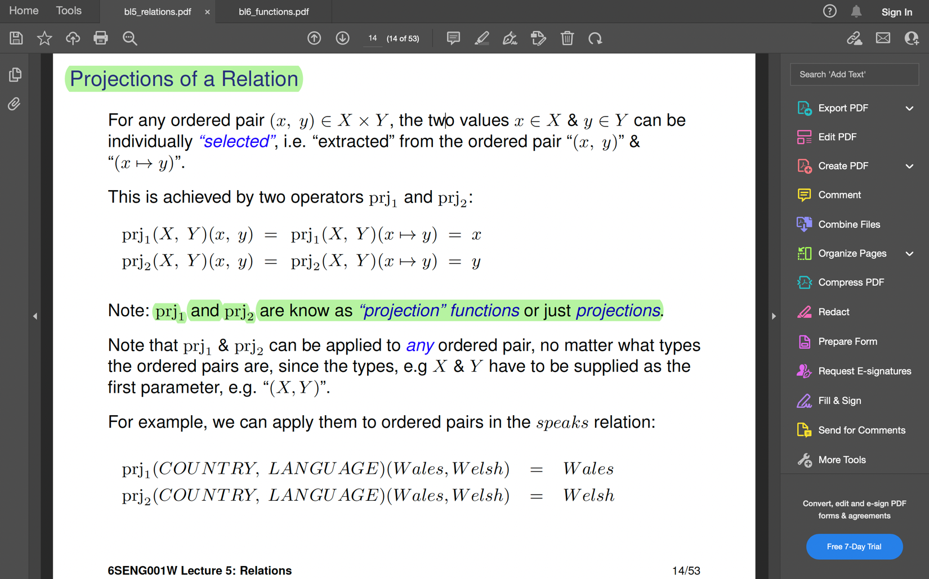

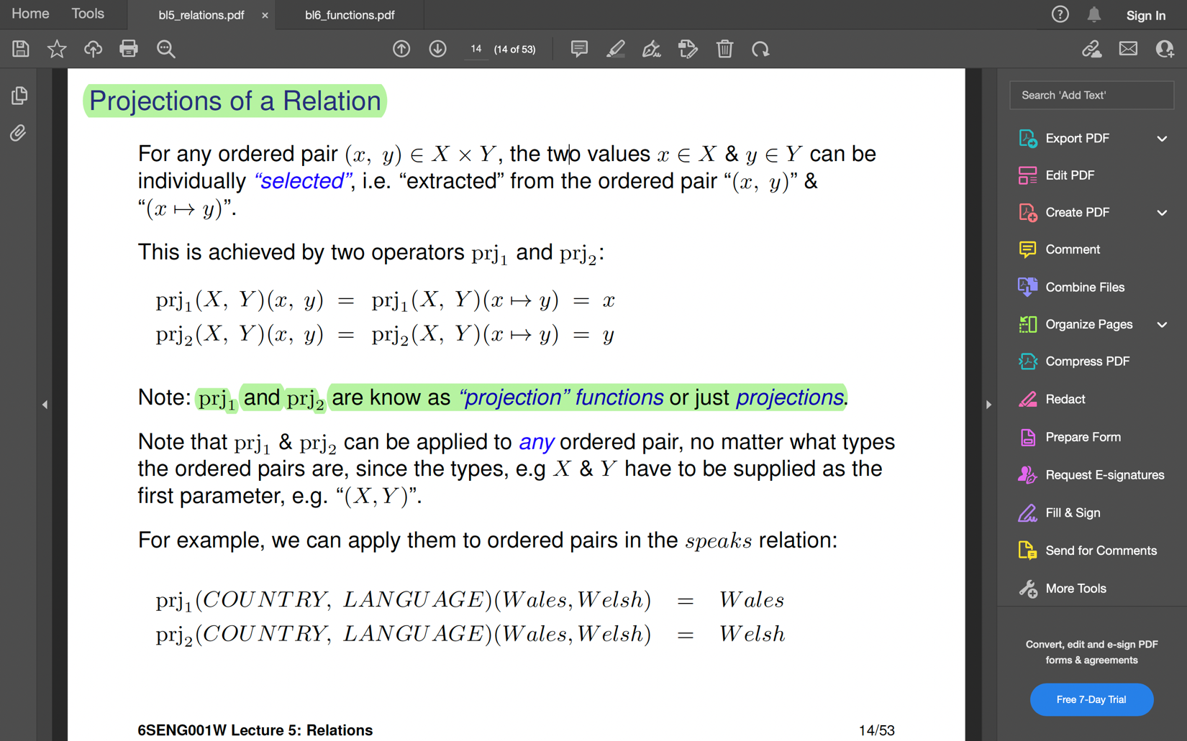

Membership 🡺 To see if a relation relates to a pair of values.

Domain (elements of the source) and Range (elements of the target)

Relational Image 🡪 What languages are spoken in Canada & Wales?

speaks [ {Canada, Wales}] = {French, English, Welsh}

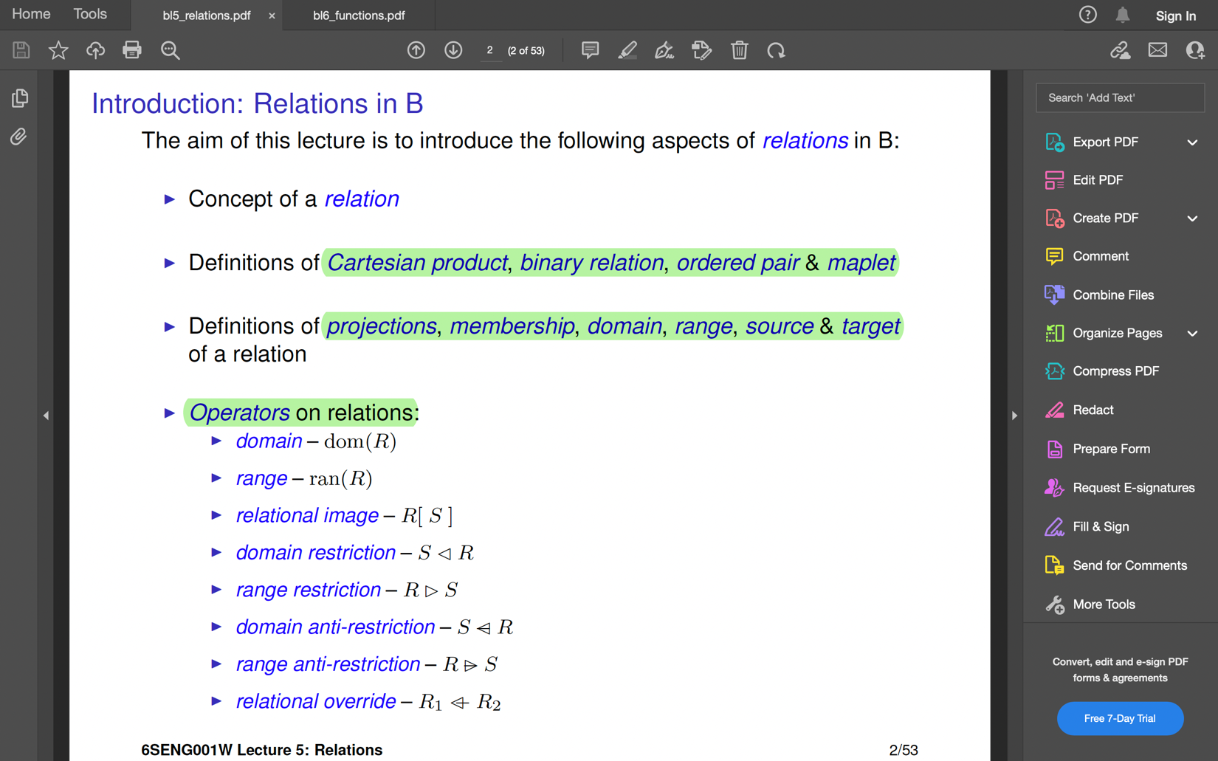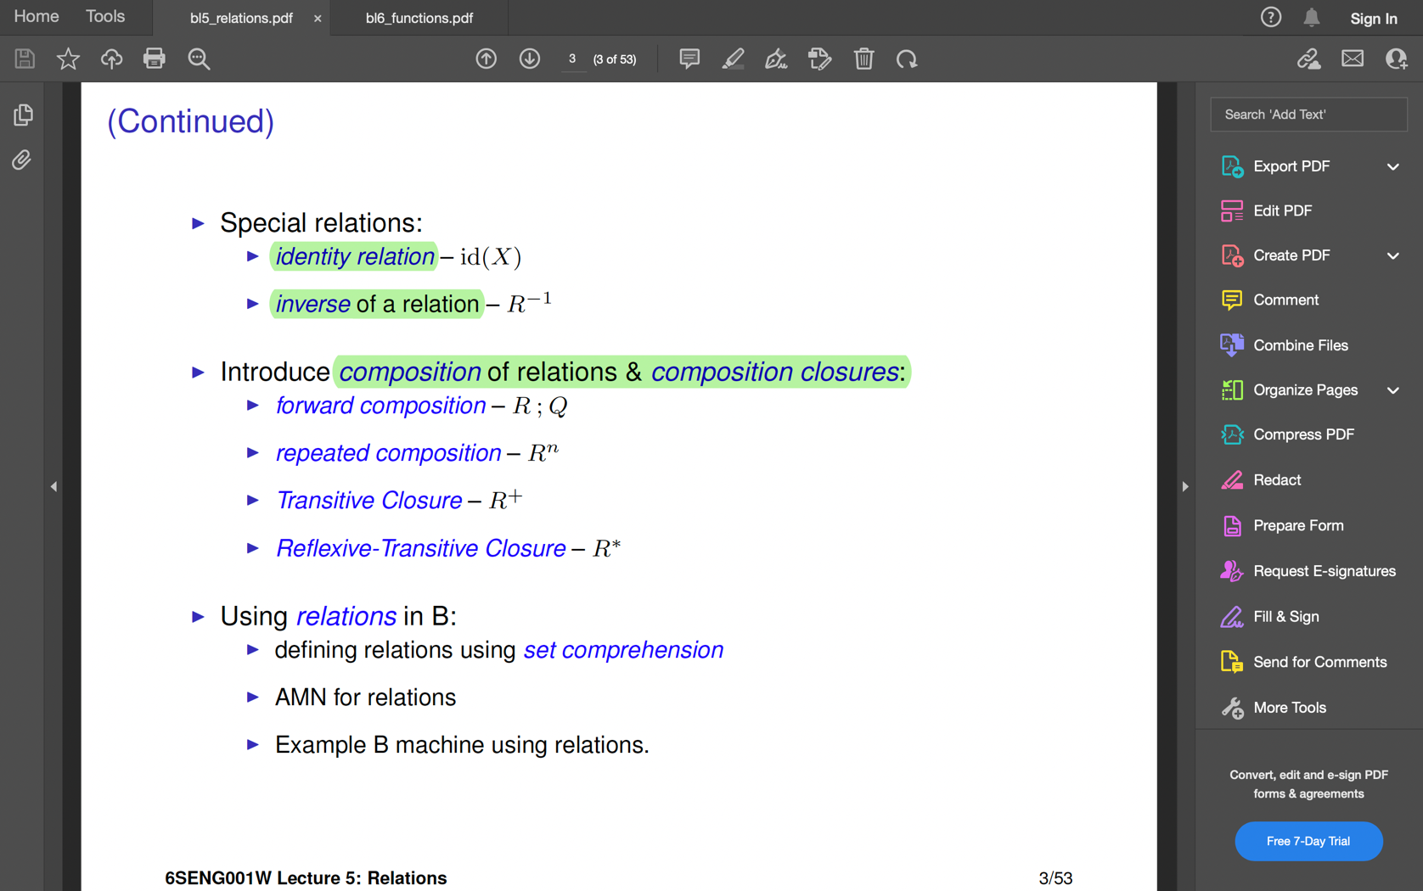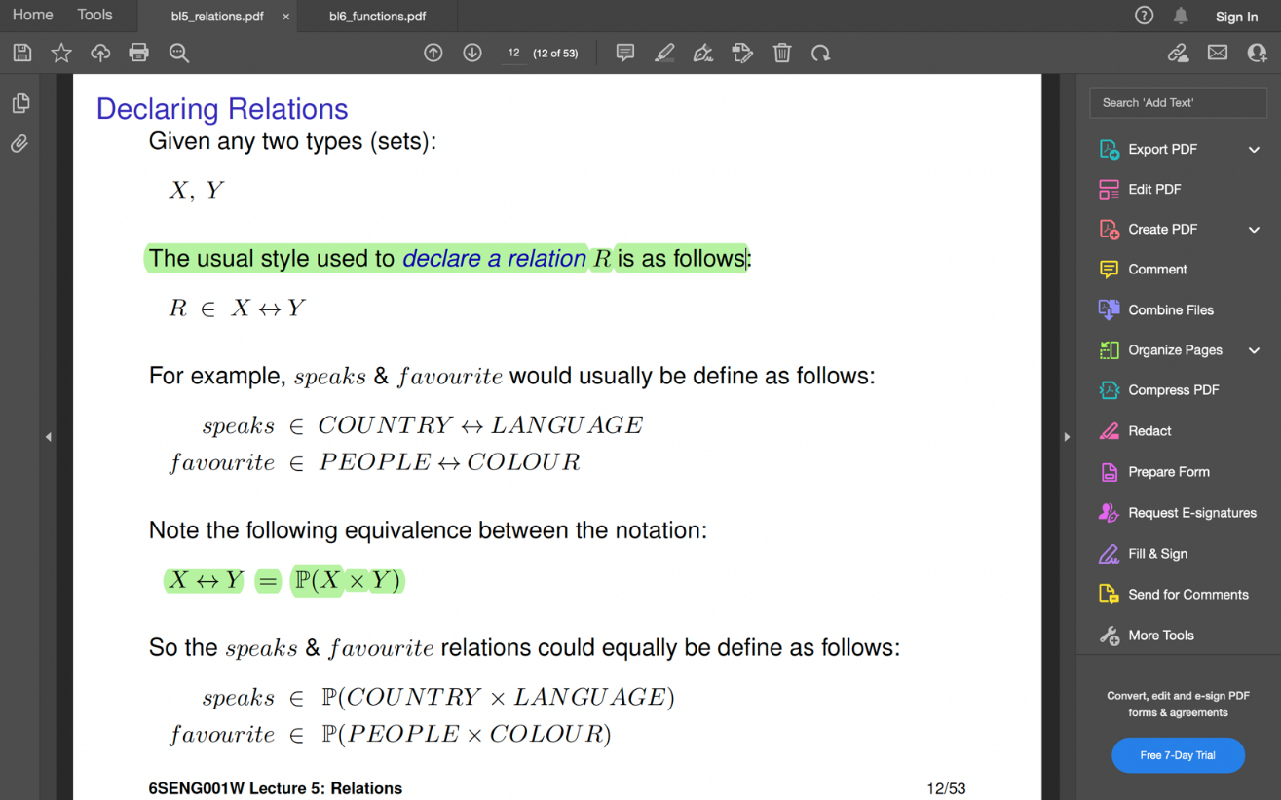

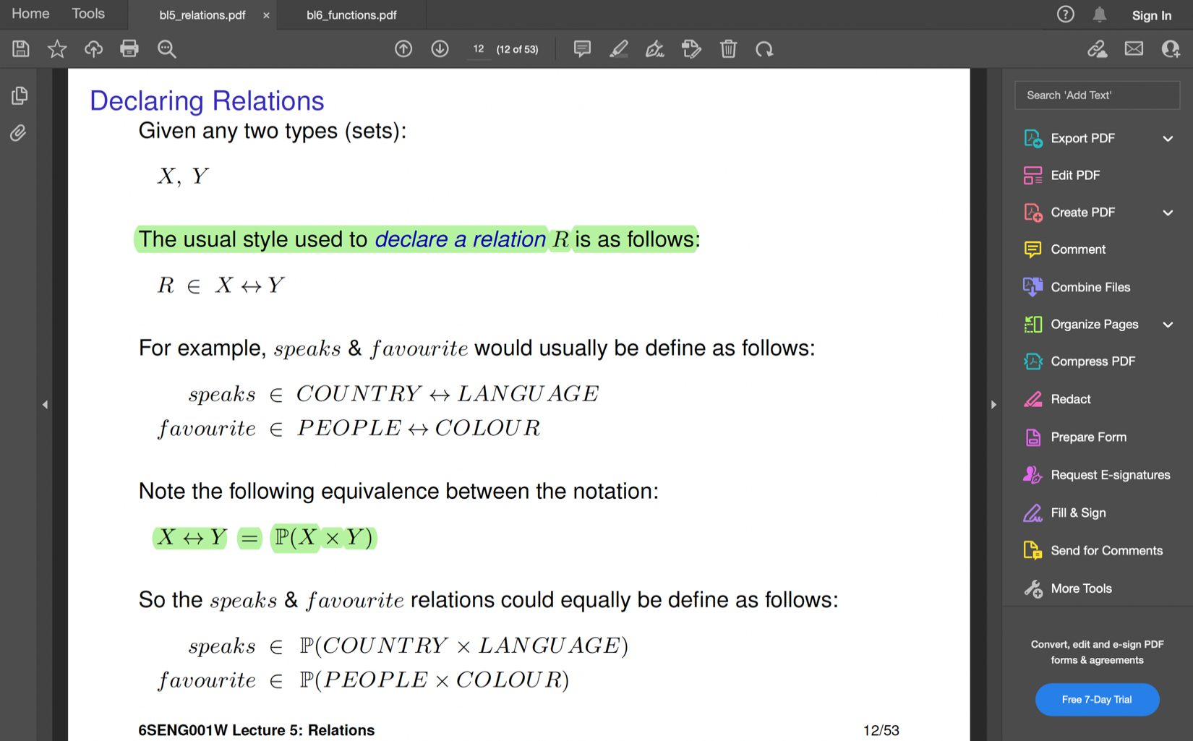

**Domain Restriction** 🡪 Used to create a new relation by **restricting** a relation to that part where the **domain** is contained in a set.

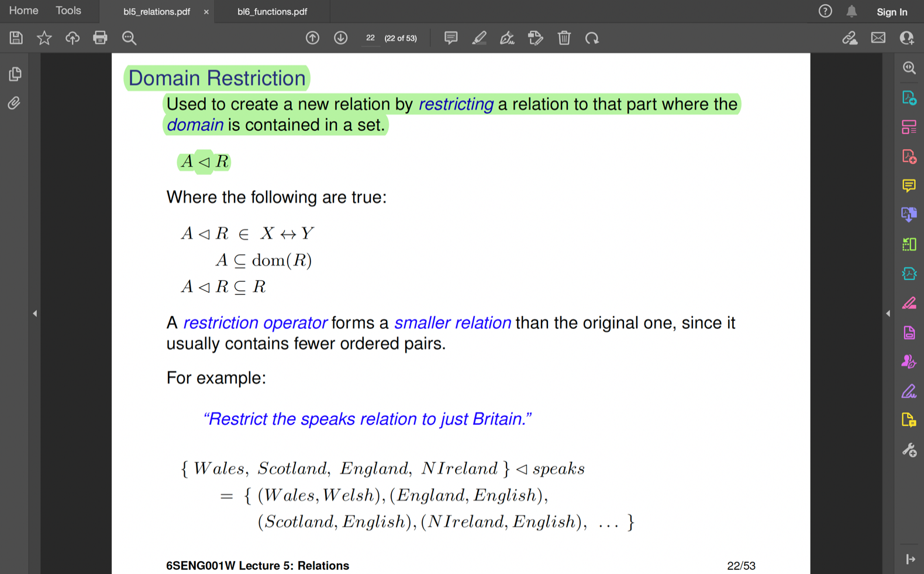

**Range Restriction** 🡪 This is used to restrict a relation R to that part where the **range** is contained in a set B.

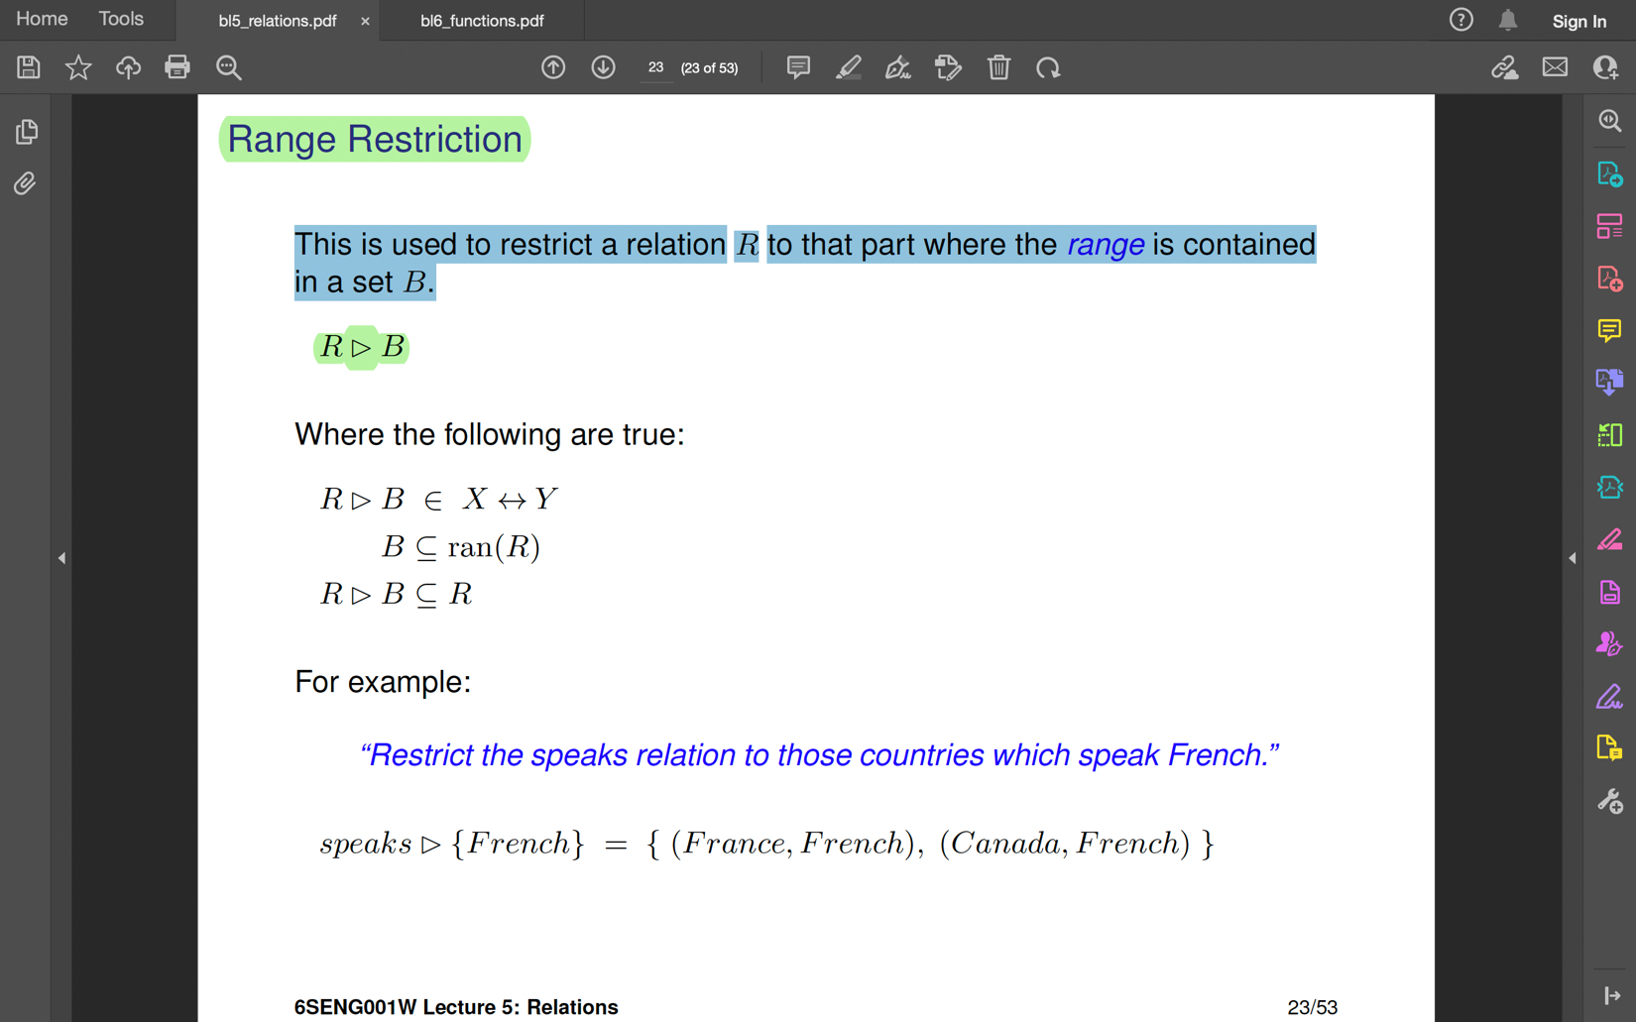

**Domain Anti- Restrictions** 🡪 also known as domain subtraction. This is used to restrict a relation to that part **where the domain is not contained** in a set.

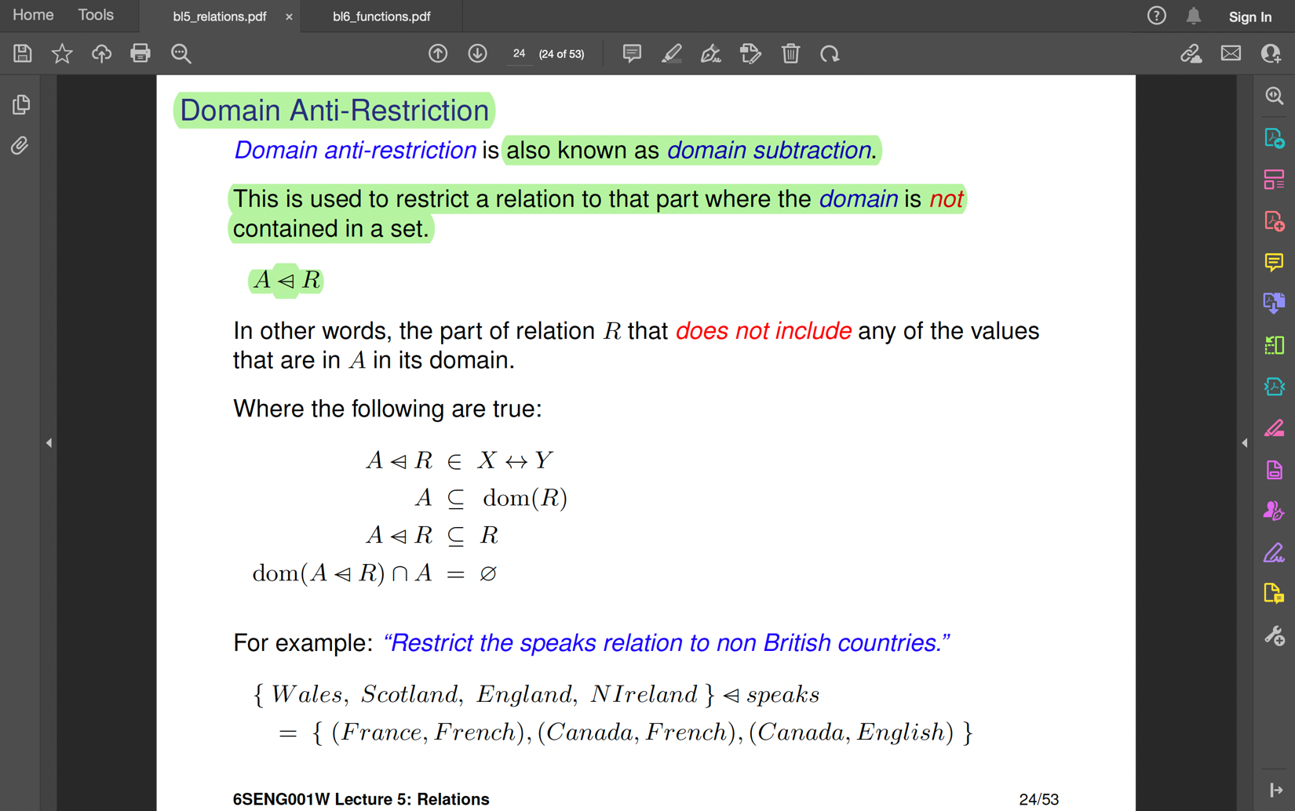

**Range Anti-Restrictions**🡪 Used to restrict a relation to that part where the **range is not contained** in a set.

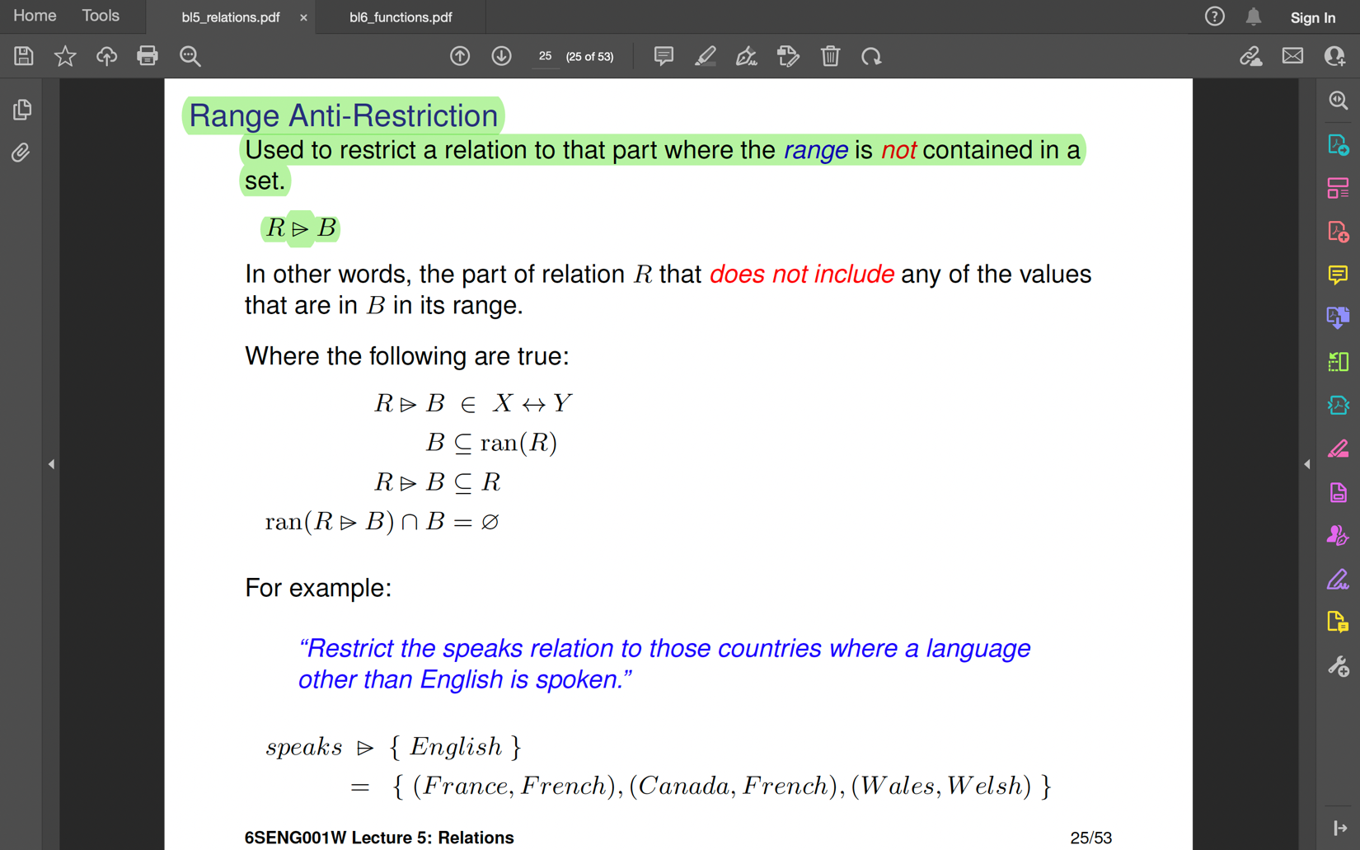

**Relational Override Operator** 🡪 A relation can be modified by adding pairs, removing pairs or by altering.

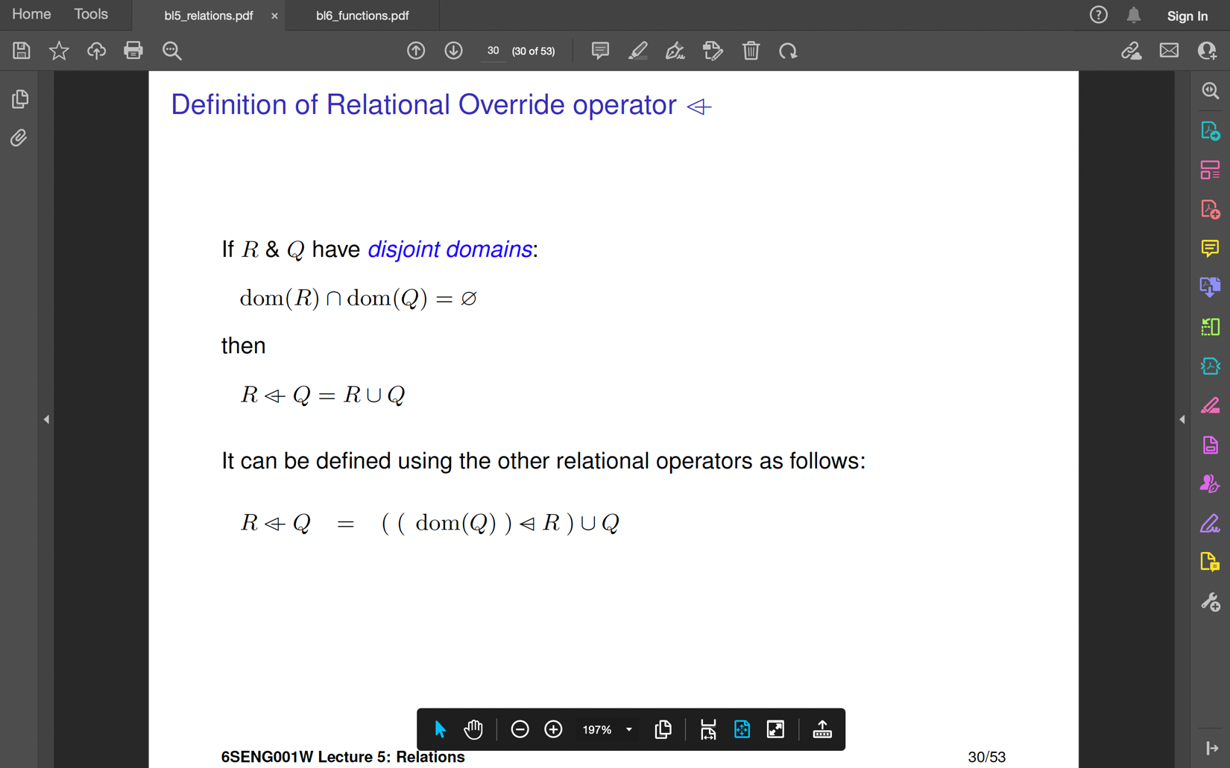

R overridden by the relation Q

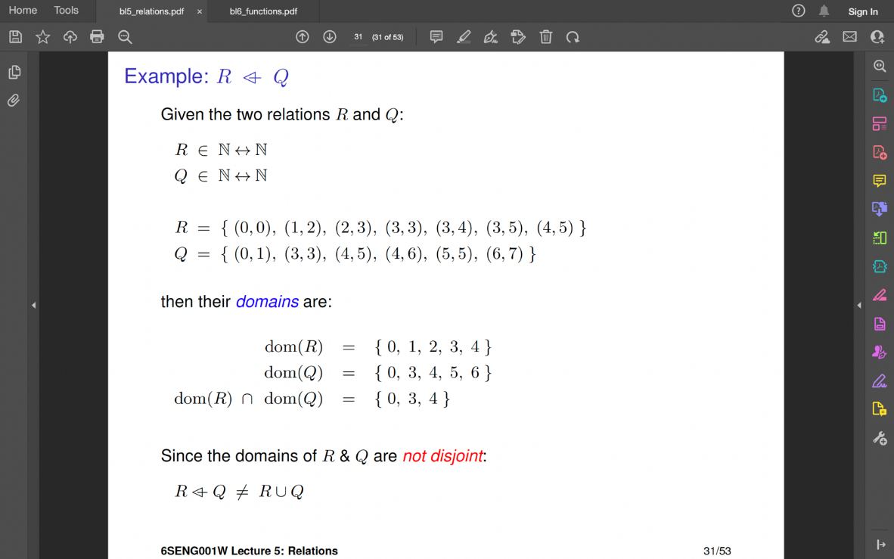

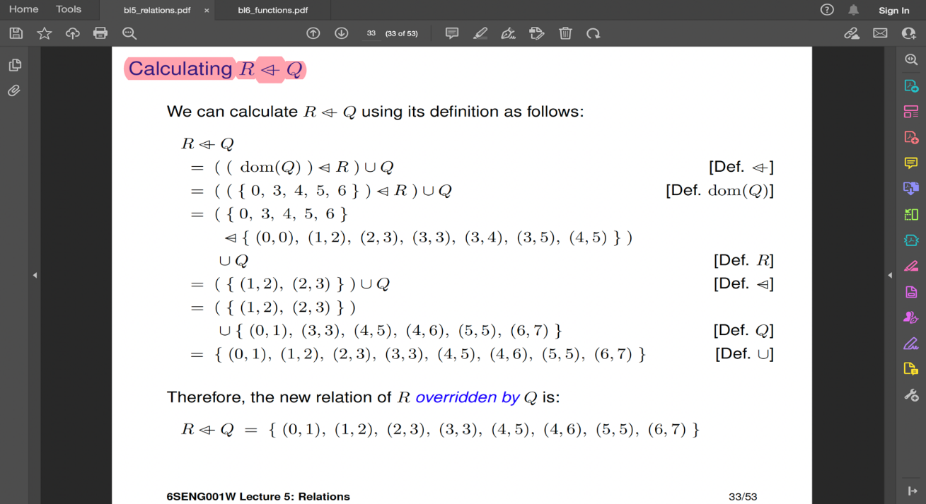

**Identity Relation** 🡪 is a relation which maps all the elements of X to themselves.

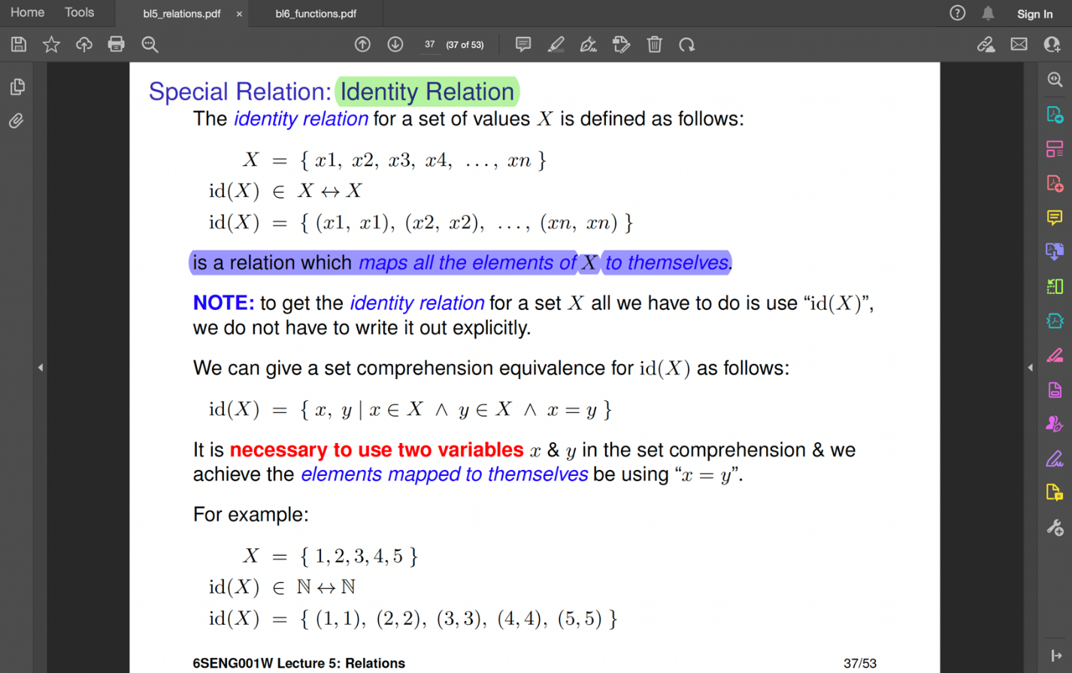

**Inverse Relation**🡪

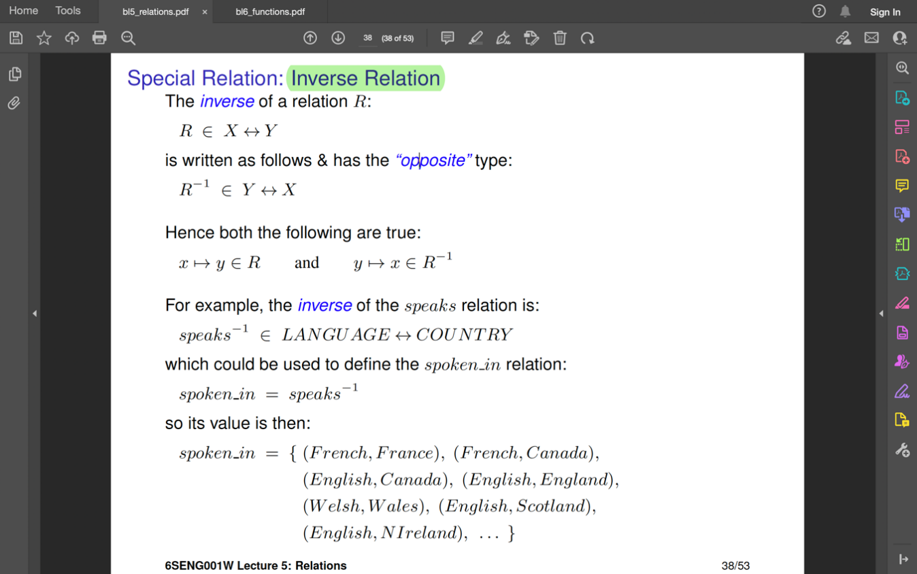

**Compositions of Relation** 🡪 Relations can be joined together by an operation called composition.

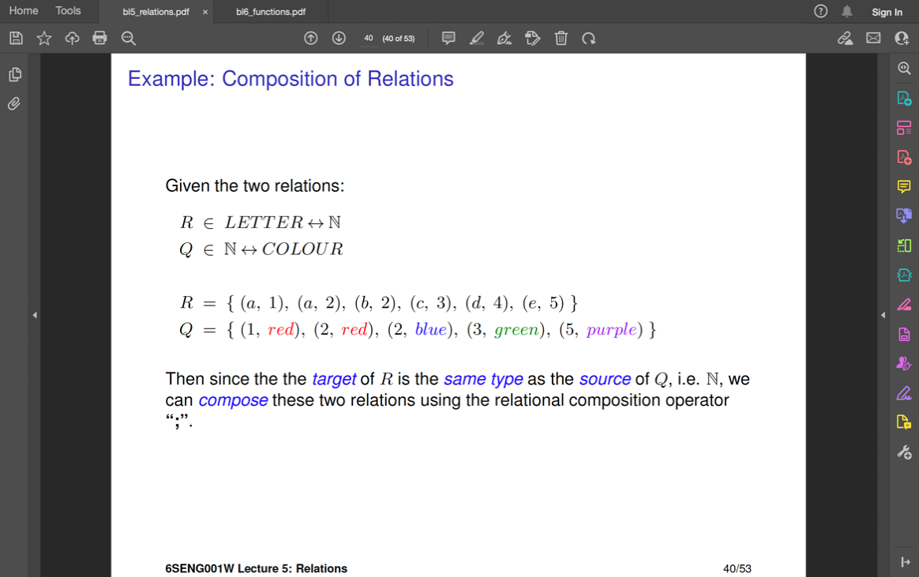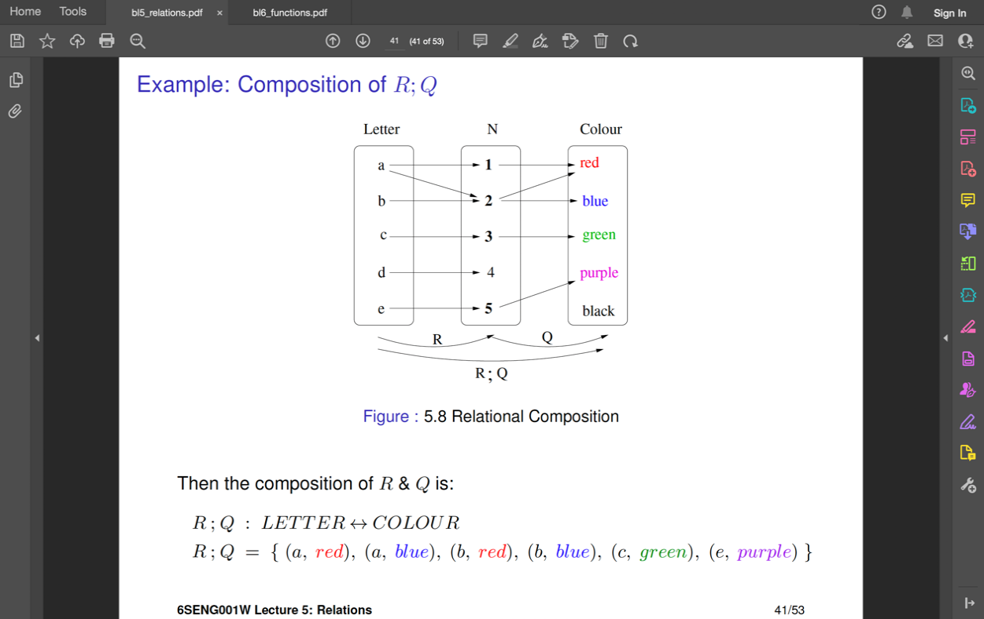

Transitive🡪

Reflexive -Transitive 🡪

